***Blood Donation system***

It’s a system that you can donate any kind of blood (Blood type, red cell, white cell) and you can request also any kind you want depends on your need.

The use should be able to sign into the system via his mobile phone and he should put all the information needed like (first name, last name, age, phone number, password, his blood type, his city, state gender) and to confirm his number he should receive a message to his number contains a number to validate it.

Once he login into the system he will be able to request a blood and donate and view history of his donation, history for requesting, and his profile details.

To allow him to donate he should ask about couple of question (have you do a surgery last 6 month, and so one). And about the requiting a blood he will put want he want if it bloods type or red cells or white cell with number of cells he needs and at what hospital or lab he wants it.

1. Context diagram  
   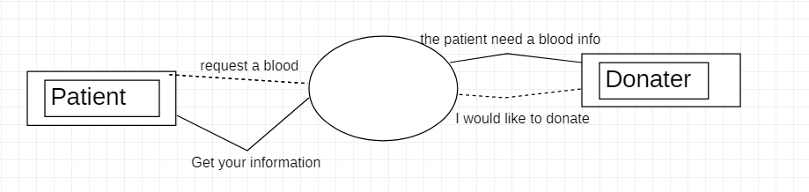
2. Use case diagram

